 Project Report Template

- INTRODUCTION
Create a social media post using canva
  - Overview
Design in canva then use content planner to plan schedule and publish social media posts directly to your favourite platforms.
  - Purpose
Social media helps your strengthen your brand and expand its
Reach and affordable ways to introduce your brand to the world.
- Problem Definition & Design Thinking
Creating content for social media easy with thousands of templates for every social channels, a drag and drop- editor graphics, fonts, shapes and more!
2.1 Empathy map

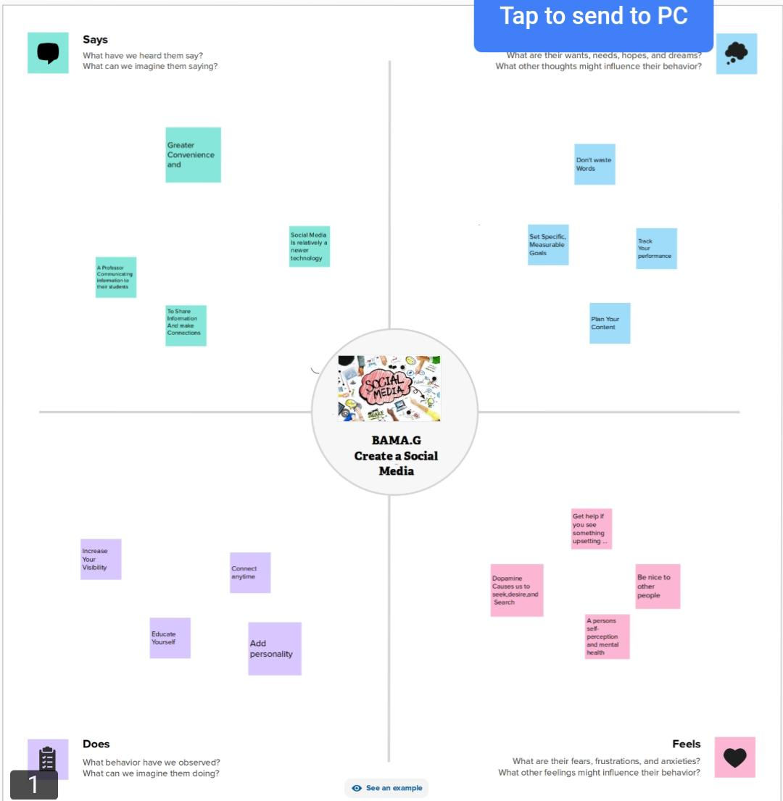
2.2 Ideation & Brainstorming Map

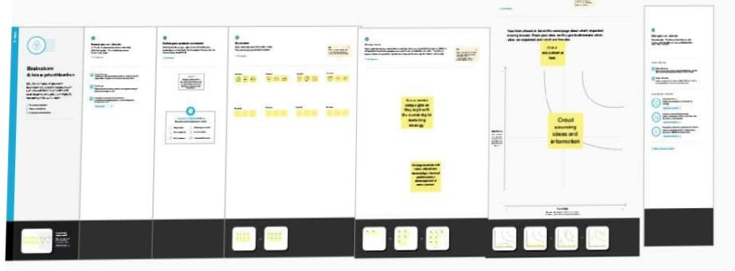

- Result


- Advantages
Social media promotes creativity.
Increase sales opportunities.
Disadvantages
Decrease in communication skills.
Getting close to depression.
- APPLICATIONS
I submit this application to express my sincere interest in the interior design for home
- CONCLUSION
We learn a lot of new things about Editing and make it useful
For others.

Project Report Template

